Parallel and Distributed Computing

CSE4001

Fall Semester 2020-21

Lab Assignment 8

**ISHAAN OHRI**

**18BCE0265**

**Aim:**

Write a C program to demonstrate the use of MPI_Bcast()

**Case 1: broadcast = 500**

**Source Code:**

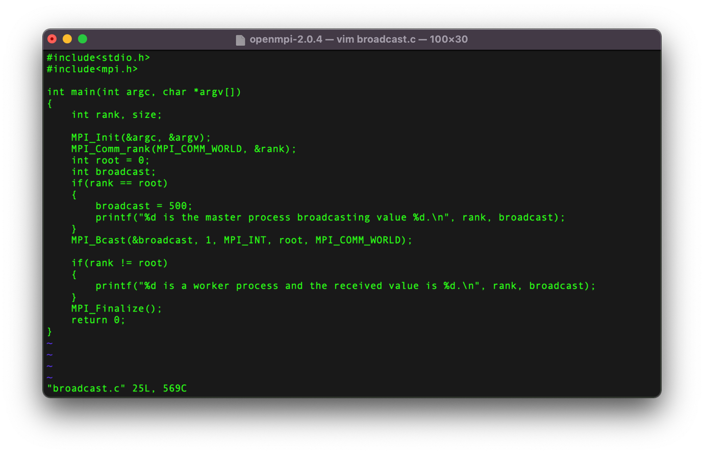**Execution:**

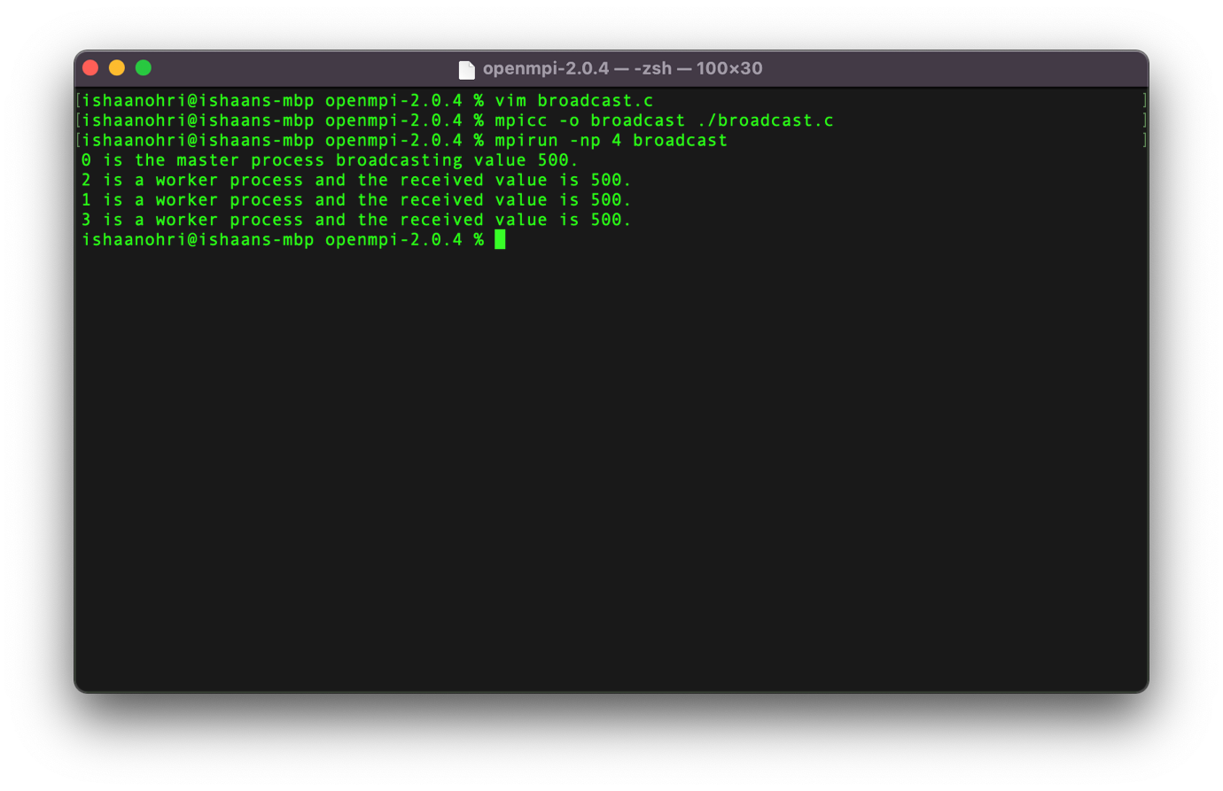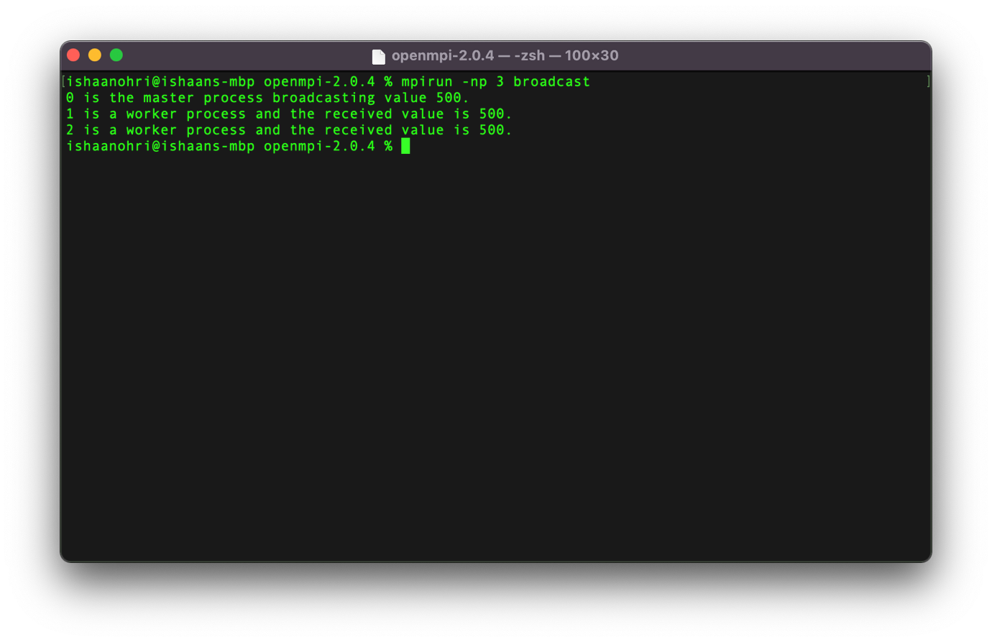**Case 2: broadcast = 200**

**Source Code:**

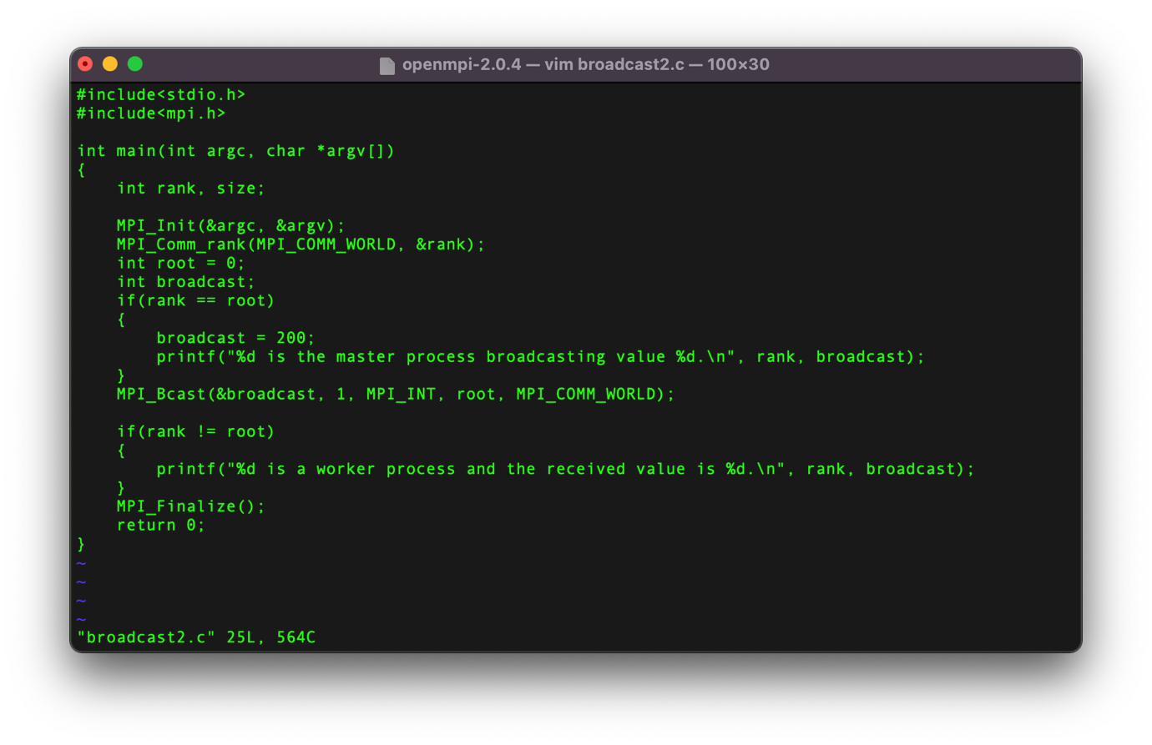

**Execution:**

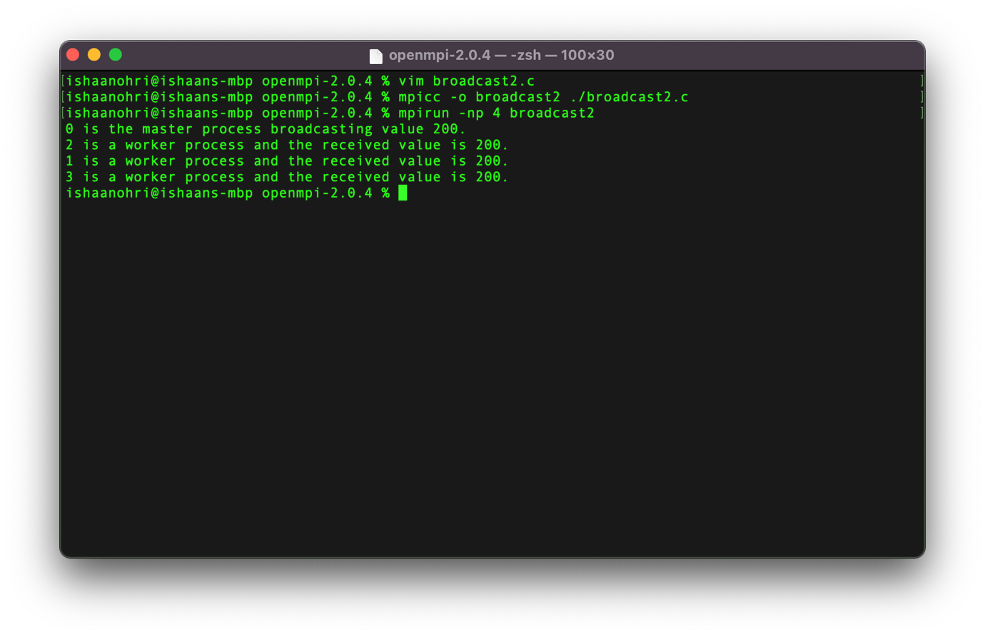

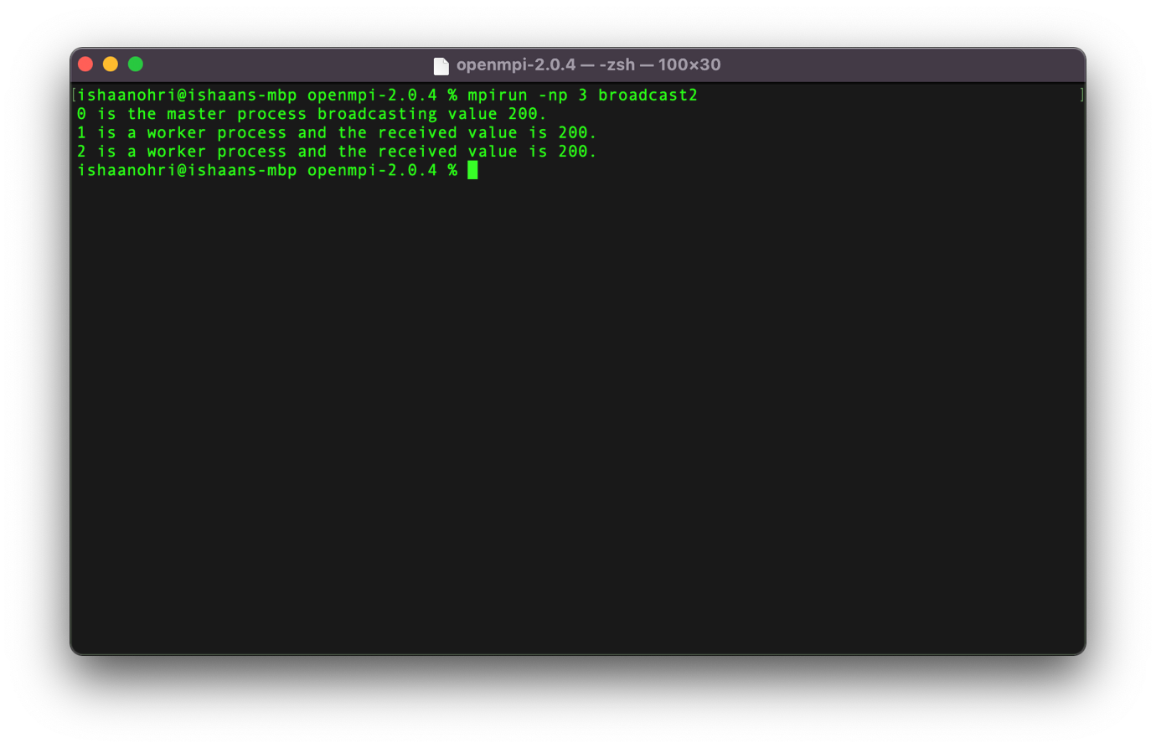

**Remarks:**

The MPI_Bcast() function helps a particular value to be broadcasted to all worker processes by the master process. It is helpful if a particular value needs to be transmitted to a lot of processes (Eg: 50), therefore saving us from writing 50 extra lines of code of MPI_Send() and MPI_Receive().

Over here we tried by sending a value of 500 in case 1 and 200 in case 2.

In the mpirun we specify the number of worker processes, over here it has been done for 4 and 3 worker processes.